23CSE202 DATABASE MANAGEMENT SYSTEMS
S3 B.Tech CSE
Department of Computer Science and Engineering
Amrita School of Computing, Amritapuri Campus

3. Database Design Document

Group No :D1
Team Members :
Roll No | Student Name
AM.SC.U4CSE25365 | GOWTHAM GOUD
AM.SC.U4CSE25364 | KUSHAL ENDALA
AM.SC.U4CSE25369 | ADITYA SAI RRARAGHAVENDRA
AM.SC.U4CSE25333 | PURI JAGANATH

Project Title :CAR RENTAL SYSTEM

3.1. Detailed description of the project
[clearly describe the scenario so that the entities, attributes, relationships, users and business rules are evident from the description]
The Car Rental Management System is designed to manage the complete process of renting vehicles. Customers can register, view available vehicles, make reservations, make payments, and provide feedback. Employees manage rentals and vehicle-related activities, while branches manage vehicles and employees at different locations.

The system consists of nine main entities: Customer, Vehicle, Reservation, Rental, Payment, Maintenance, Employee, Branch, and Feedback. These entities are connected through relationships that maintain customer details, vehicle information, reservations, rentals, payments, maintenance records, employee details, branch information, and customer feedback.

The system ensures that vehicle availability, reservations, rentals, payments, maintenance, and feedback are properly recorded and managed.

3.2. ER Diagram
[entities, attributes, relationships, keys, cardinality and participation have to be accurately represented]
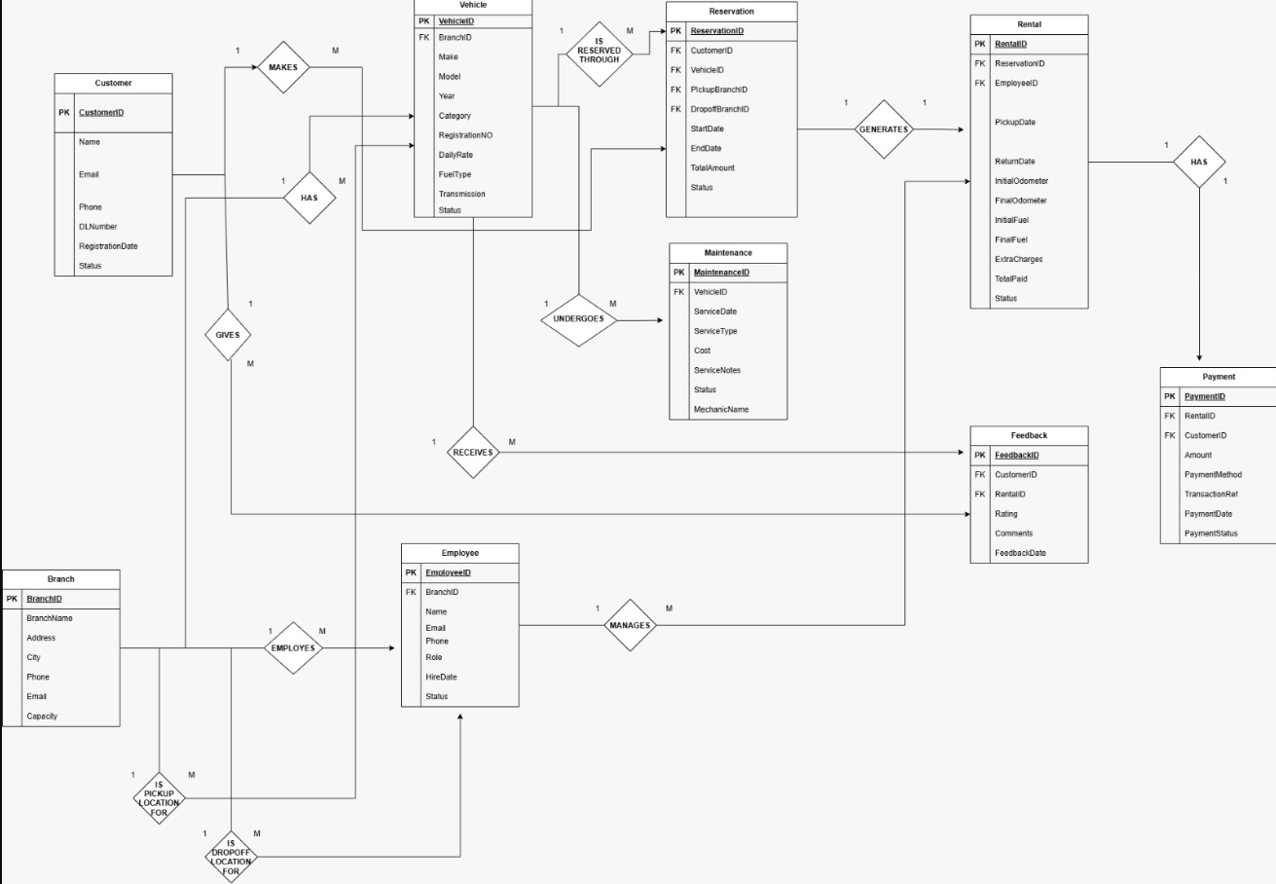

3.3 Relational Schema
[Correctly converts all entities, relationships, cardinality etc to relational schema]

The ER model is converted into the following relational schema:

1. CUSTOMER
Customer(CustomerID, Name, Email, Phone, Address)

2. VEHICLE
Vehicle(VehicleID, VehicleName, VehicleType, Model, RentalRate, AvailabilityStatus, BranchID)

3. RESERVATION
Reservation(ReservationID, CustomerID, VehicleID, PickupBranchID, DropoffBranchID, StartDate, EndDate, Status)

4. RENTAL
Rental(RentalID, ReservationID, EmployeeID, PickupDate, ReturnDate, TotalAmount)

5. PAYMENT
Payment(PaymentID, RentalID, PaymentDate, Amount, PaymentMethod, PaymentStatus)

6. MAINTENANCE
Maintenance(MaintenanceID, VehicleID, MaintenanceDate, Description, Cost)

7. EMPLOYEE
Employee(EmployeeID, Name, Email, Phone, Role, BranchID)

8. BRANCH
Branch(BranchID, BranchName, City, Phone, Email, Address, Capacity)

9. FEEDBACK
Feedback(FeedbackID, CustomerID, VehicleID, Rating, Comments, FeedbackDate)

Primary Keys:
CustomerID, VehicleID, ReservationID, RentalID, PaymentID, MaintenanceID, EmployeeID, BranchID and FeedbackID.

Foreign Keys:
Vehicle.BranchID → Branch.BranchID
Reservation.CustomerID → Customer.CustomerID
Reservation.VehicleID → Vehicle.VehicleID
Reservation.PickupBranchID → Branch.BranchID
Reservation.DropoffBranchID → Branch.BranchID
Rental.ReservationID → Reservation.ReservationID
Rental.EmployeeID → Employee.EmployeeID
Payment.RentalID → Rental.RentalID
Maintenance.VehicleID → Vehicle.VehicleID
Employee.BranchID → Branch.BranchID
Feedback.CustomerID → Customer.CustomerID
Feedback.VehicleID → Vehicle.VehicleID

3.4 Normalization and Functional dependency analysis
[Correctly identifies relevant FDs and explains their significance
Justify the selection of candidate keys with attribute closure
Demonstrate the normalization process starting from 1NF to BCNF or higher with proper justification]

Functional Dependencies

The functional dependencies identified in the database are:

1. CustomerID → Name, Email, Phone, Address
2. VehicleID → VehicleName, VehicleType, Model, RentalRate, AvailabilityStatus, BranchID
3. ReservationID → CustomerID, VehicleID, PickupBranchID, DropoffBranchID, StartDate, EndDate, Status
4. RentalID → ReservationID, EmployeeID, PickupDate, ReturnDate, TotalAmount
5. PaymentID → RentalID, PaymentDate, Amount, PaymentMethod, PaymentStatus
6. MaintenanceID → VehicleID, MaintenanceDate, Description, Cost
7. EmployeeID → Name, Email, Phone, Role, BranchID
8. BranchID → BranchName, City, Phone, Email, Address, Capacity
9. FeedbackID → CustomerID, VehicleID, Rating, Comments, FeedbackDate

These dependencies indicate that the primary key of each relation uniquely determines the remaining attributes of that relation.

Candidate Keys and Attribute Closure

The candidate key for each relation is its corresponding ID attribute.

For example:

CustomerID⁺

= {CustomerID, Name, Email, Phone, Address}

Therefore, CustomerID is a candidate key of CUSTOMER.

Similarly:

VehicleID⁺

= {VehicleID, VehicleName, VehicleType, Model, RentalRate, AvailabilityStatus, BranchID}

ReservationID⁺

= {ReservationID, CustomerID, VehicleID, PickupBranchID, DropoffBranchID, StartDate, EndDate, Status}

RentalID⁺

= {RentalID, ReservationID, EmployeeID, PickupDate, ReturnDate, TotalAmount}

PaymentID⁺

= {PaymentID, RentalID, PaymentDate, Amount, PaymentMethod, PaymentStatus}

MaintenanceID⁺

= {MaintenanceID, VehicleID, MaintenanceDate, Description, Cost}

EmployeeID⁺

= {EmployeeID, Name, Email, Phone, Role, BranchID}

BranchID⁺

= {BranchID, BranchName, City, Phone, Email, Address, Capacity}

FeedbackID⁺

= {FeedbackID, CustomerID, VehicleID, Rating, Comments, FeedbackDate}

Since each ID's closure contains all the attributes of its respective relation, the ID is a candidate key.

Normalization

First Normal Form (1NF):

All relations satisfy 1NF because each attribute contains a single atomic value and there are no repeating groups or multi-valued attributes.

Second Normal Form (2NF):

All relations satisfy 2NF because they are in 1NF and every non-key attribute is fully functionally dependent on the complete primary key. Since the relations have single-attribute candidate keys, partial dependencies do not occur.

Third Normal Form (3NF):

All relations satisfy 3NF because they are in 2NF and there are no transitive dependencies among non-key attributes. Each non-key attribute depends directly on the primary key of its relation.

Boyce-Codd Normal Form (BCNF):

The relations satisfy BCNF because for every non-trivial functional dependency, the determinant is a candidate key. Hence, there are no dependencies where a non-key attribute determines another attribute.

Final Normalized Relations

The final relations after normalization are:

- CUSTOMER(CustomerID, Name, Email, Phone, Address)
- VEHICLE(VehicleID, VehicleName, VehicleType, Model, RentalRate, AvailabilityStatus, BranchID)
- RESERVATION(ReservationID, CustomerID, VehicleID, PickupBranchID, DropoffBranchID, StartDate, EndDate, Status)
- RENTAL(RentalID, ReservationID, EmployeeID, PickupDate, ReturnDate, TotalAmount)
- PAYMENT(PaymentID, RentalID, PaymentDate, Amount, PaymentMethod, PaymentStatus)
- MAINTENANCE(MaintenanceID, VehicleID, MaintenanceDate, Description, Cost)
- EMPLOYEE(EmployeeID, Name, Email, Phone, Role, BranchID)
- BRANCH(BranchID, BranchName, City, Phone, Email, Address, Capacity)
- FEEDBACK(FeedbackID, CustomerID, VehicleID, Rating, Comments, FeedbackDate)

Thus, the database is organized into normalized relations up to BCNF, minimizing data redundancy and reducing insertion, deletion, and update anomalies.

